Project #2—Musa Harshuk

**Work plan:**

**1- table analysis and question asking**

**2- technical analysis (SQL,Excel,tableau)**

**3- visualization**

**4- document and making Data into words**

**5 – finalizing and submitting the project**

**1- table analysis**

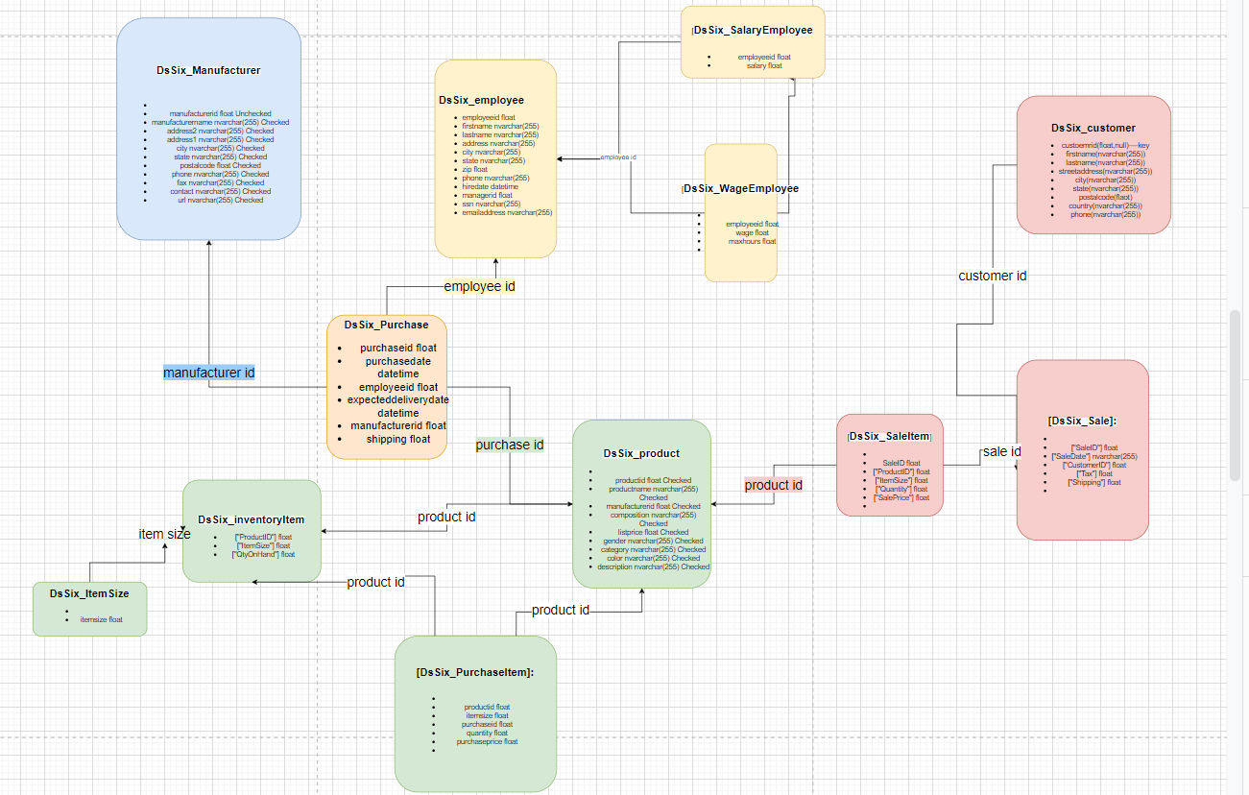

1- question asking:

* What are the characteristics of our biggest customers
* What is our most popular product and which product is give us the most income
* And to which category they are from.
* In which states do we have the most success with our products
* Which manufacturer bring the most sales to the company

2

* What are the characteristics of our biggest customers

Our biggest costumers are from the east coast and we don’t have much data about them

Conclusion we need to gather that about our customers

Was done in tableau

* 4 Which manufacturer bring the most sales to the company

Was done in tableau

What is our most popular product and which product is give us the most income

* And to which category they are from.

select ["ProductID"],count( saleID)amount from DsSix_SaleItem

group by ["ProductID"]

order by amount desc

select distinct * from

(select ["ProductID"],amount_of_income,cost,st.amount [amount of orders],(amount_of_income)-(cost) gross from

(select ["ProductID"],avg(amount_of_income) amount_of_income,avg(amount) amount from

(select distinct ["ProductID"],["ItemSize"],["Quantity"],["SalePrice"],count( SaleID) over (partition by ["ProductID"]) amount

,count( SaleID) over (partition by ["ProductID"])*["SalePrice"] amount_of_income

from DsSix_SaleItem)st250

group by ["ProductID"] )st

join

(select distinct productid,count(purchaseid)over (partition by productid)amount

,count(purchaseid)over (partition by productid)*purchaseprice cost

from DsSix_PurchaseItem)pt

on st.["ProductID"]=pt.productid)sq

join [dbo].[DsSix_product] dps on sq.["ProductID"]=dps.productid

where gross>(select distinct PERCENTILE_CONT(0.90)within group(order by gross) over() from

(select ["ProductID"],(amount_of_income)-(cost) gross from

(select ["ProductID"],avg(amount_of_income) amount_of_income,avg(amount) amount from

(select distinct ["ProductID"],["ItemSize"],["Quantity"],["SalePrice"],count( SaleID) over (partition by ["ProductID"]) amount

,count( SaleID) over (partition by ["ProductID"])*["SalePricef"] amount_of_income

from DsSix_SaleItem)st12

group by ["ProductID"])st

join

(select distinct productid,count(purchaseid)over (partition by productid)amount

,count(purchaseid)over (partition by productid)*purchaseprice cost

from DsSix_PurchaseItem)pt

on st.["ProductID"]=pt.productid)sq)

* In which states do we have the most success with our products

select country, state,count(distinct customerid)[amount of customers]

, sum(sq.amount)[amount of orders]

,cast(sum(sq.amount)as float)/count(distinct customerid) [order rate] from

(select distinct ds.* , sq.amount from DsSix_customer ds

join

(select customerid,amount from

(select distinct d.customerid, count(distinct s.["SaleID"])amount from DsSix_customer d

join [dbo].[DsSix_Sale] s ON s.["CustomerID"]=d.customerid group by d.customerid)q2

where amount>(select distinct PERCENTILE_CONT(0.90)within group (order by amount) over() from

(select distinct d.customerid, count(distinct s.["SaleID"])amount from DsSix_customer d

join [dbo].[DsSix_Sale] s ON s.["CustomerID"]=d.customerid

group by d.customerid)q1))sq on sq.customerid = ds.customerid)sq

group by country ,state